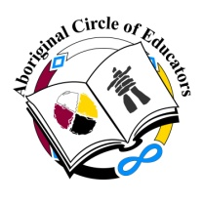
REGISTRATION FORM

Registration Includes Teachings, Healthy Breaks and Feast
All Materials and Supplies are provided

Name:
Organization/School:
Email Address:
Phone Number:
Street Address:
City, Prov., Postal Code:
Event:
Method of Payment: | Cheque/EFT: | Purchase Order: |  | Invoice:

Receipts will be emailed to the email address provided, unless otherwise indicated

Workshop Registration Fees

Members $300.00

Non-Members $350.00

Tobacco offerings to the animals are optional

For more information please Contact Deborah Clark, Executive Director, below

Please make cheque payable to:

Membership Form

Please Indicate: New Member: ______ Renewal: _______

Name:
Profession/Occupation/Course of Study:
Place of Employment/Study:
Address [Work/Home]:
City, Province, Postal Code:
Contact Numbers: | [W] | [H] | [C]
Email [Work/Personal]:

Optional Information:
Cultural Group: | Languages Spoken:

Conference: | Awards: | Banquet: | Retreat: | Workshops: | Bingos: | Other:
Workshop/Seminar Ideas:

Please return to: Aboriginal Circle of Educators
715 Main Street
Winnipeg, MB R3B 3N7
Email: members@aboriginalcircleofeducators.ca

Annual [July 1-June 30] Membership

Miigwech! Boozhoo! Aaniin! Tánisi! Han! Wotziye! Hau! Merci! Thank you!

