Congratulations to this year’s Education Award Recipients

CATEGORY | RECIPIENT
Elder | Florence Paynter
Honouring Our Allies | Sister Margaret Hughes
 | Kim Midford
Trailblazer/  Lifetime Achievement | Michael Champagne
 | Renée McGurry
Young Leaders | Crystal Byer
Leadership Sustaining Our Ways | Jennifer Storm
Research/Curriculum Development | Diana Hooper
 | Niigaanwewidam James Sinclair
Aboriginal Language Education | Wab Kinew
 | Jason Parenteau
Spiritual/Cultural Education | Ko’ona Cochrane

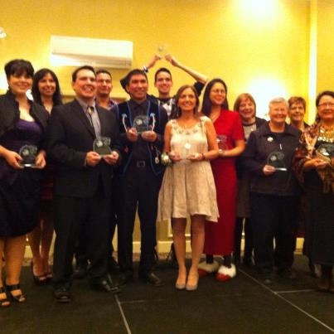

Inside This Issue

A.C.E. Education Award Recipients 1
Favourite Resources 2
Cultural Workshops 2
Membership Benefits 3
Meet the Executive 3
Meeting Dates 4
Jump Math Training Opportunity 4

Have you renewed your A.C.E. Membership yet? Memberships are only $20 per year and are valid from July 1 to June 30. They entitle you to discounts at workshops and the Conference and Banquet. You are also able to access the Members’ Only section where a number of resources are tucked away.

What’s Your Favourite Resource?

Do you have a particular resource you would like to share or a lesson plan you find particularly helpful? Send them to Members@aboriginalcircleofeducators.ca and we will include them in the next newsletter.
We like the resources available at the Libraries Branch. Have you talked to the helpful staff recently?

Cultural Workshops are Coming!

Ko’ona Cochrane’s Workshop:
Bringing the Outside In

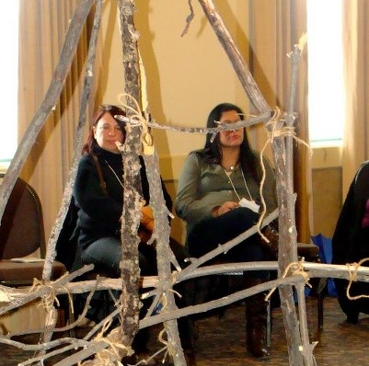
A.C.E. has secured funding for a series of cultural workshops for educators and community members. Beading, jigging, drum making and star blanket making will be offered Participants will learn the basics of the activity as well as the traditional teachings.

Educators will also have access to lesson plans and resources for classroom teaching. If you are interested in participating in any of these workshops, please contact the A.C.E. Office, 1.204.772.2231, or
Email: workshops@aboriginalcircleofeducators.ca.

If there is a workshop you would like to see, please let us know.

The rhythm of drumming is easy for our bodies to take in as was the rhythm of our mother's heartbeat.

Interested in networking and sharing resources?

A Professional Learning Network could be the answer.
A.C.E. can help with resources, contacts and more...

Meet the 2013 Executive

Our new executive members are:

Co-Chairs
Renée McGurry and Rose Bird

Treasurer, Brenda Muswagon

Secretary, Shirley Delorme Russell

Thanks to Food for Thought which catered repast of warm food and luscious desserts for the Annual General Meeting

Calling All Members!

As an A.C.E. Member, you have access to all kinds of interesting things, not only our Conference, Awards Banquets and workshops, but to our Meetings which always involved committed people and great food!

Meetings are usually held at the A.C.E. Offices, 2nd Floor- 765 Main Street at 4:15 pm. First comes the food and the chat with the meeting proper starting at about 4:30. Deborah loves to cook and usually has a soup or stew, bannock and salad available to those who make the trek. Latecomers be warned, there aren’t often leftovers.
A.C.E. is looking for a tag line …
”Sustaining Our Ways: …”
If you have an idea, post it on our Facebook page

Win and get a certificate to Elements Restaurant

A.C.E. Meeting Dates 2012-13

Conference Committee Meetings:

[Held the First Wednesday of most Months]

Interested in lending a Hand? Join us

- January 23, 2013
- March 6, 2013
- April 3, 2013
- June 5, 2013
Membership
Meetings:

[Held the Second Tuesday of every Month]

Bring a friend or colleague!

- March 12, 2013
- April 9, 2013
- May 14, 2013
- June 11, 2013

In addition to the Meeting Dates listed below, there is also a PATH Meeting, held in the latter part of August. This all day meeting offers a fried fish and potluck dish Lunch as well as Nutrition Breaks.

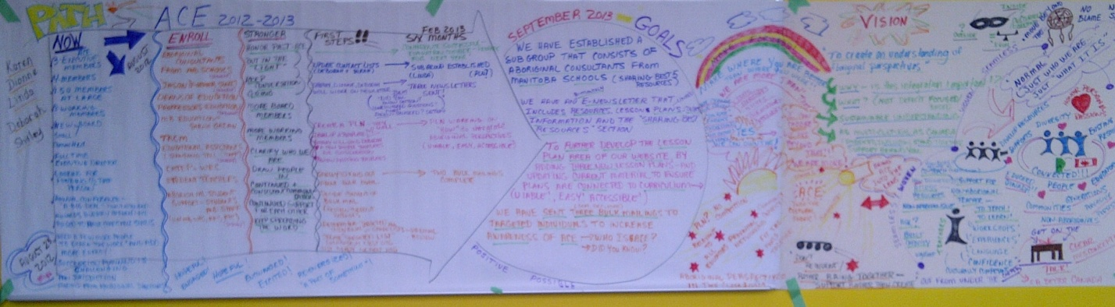

The 2012-2013 PATH

JUMP Math is accepting applications for the National Book Fund. This program gives free training, resources and support to educators serving students in high needs communities. If you feel can take advantage of this great opportunity please apply. Jennifer Yap will be happy to answer any questions and can be reached at 416-596-7716 x 229 or by email at jennifer.yap@jumpmath.org

