Don’t Miss Our 10th Annual Conference
Early Bird Registration
Now Open!

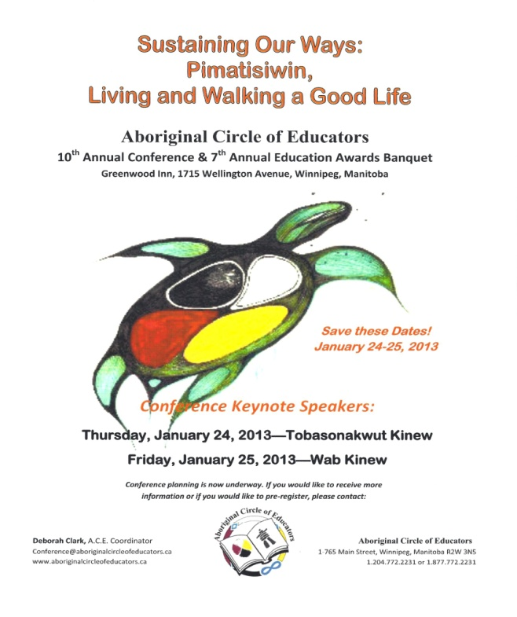
Thursday’s Keynote Speaker,
Tobasinakwut Kinew,
Reflects on the theme of
Traditional/Elder Teachings.
Friday’s Keynote Speaker, Wab Kinew,
Reflects the theme of
Innovative/Sustainable Programming.

Our workshops will be resource rich, informative and hands-on. Presenters include Myra Laramee, Fred Ford, Gloria Beckman, Michelle Johnson, Haven Stumpf, Michael Champagne, Kelly Fontaine, and others
Check out the website, www.aboriginalcircleofedcators.ca,
for more information
Early Bird Registration Packages are available on the A.C.E. Website.
They are a great value for Members!
Check it out today

The Nomination Deadline for the A.C.E. Education Awards is October 1, 2012…

Nominate someone now
The Nomination Package is on the website: www.aboriginalcircleofeducators.ca

Did You Know?

A.C.E. is a great option if you are looking to belong to a PLN?

Have you renewed your A.C.E. Membership yet? Memberships are only $20 per year and are valid from July 1 to June 30. They entitle you to discounts at workshops and the Conference and Banquet. You are also able to access the Members’ Only section where a number of resources are tucked away.

Inside This Issue

Conference Information 1
Nomination Information 1
Favourite Resources 2
More Event Information 2
Workshops 3
Membership Update 4
Meeting Dates 4

The Indigenous Writers Festival is October 11-13, 2012
Check it out on facebook
What Is Your Favourite Resource?
We would like to include your favourite resources in our upcoming newsletters and on the Website.
Do you have a particular resource you would like to share or a lesson plan you find particularly helpful? Send them to Membership@aboriginalcircleofeducators.ca and we will include them in the next newsletter.
If finding resources makes you crazy and trying to evaluate their useful is stressful come to the A.C.E. Conference where we have several workshops on the subject. Whether you want to know how to better evaluate them, find them online or in print, we have a workshop for you!

What Did You Do Last Summer?

Several A.C.E. Members spent a day brainstorming the PATH for the upcoming year. The day was manageable thanks to the wellness breaks and in no small part to the Fish Fry and Potluck Lunch that was enjoyed by all who attended. Thanks to Brenda Muswagon for frying all the fish!
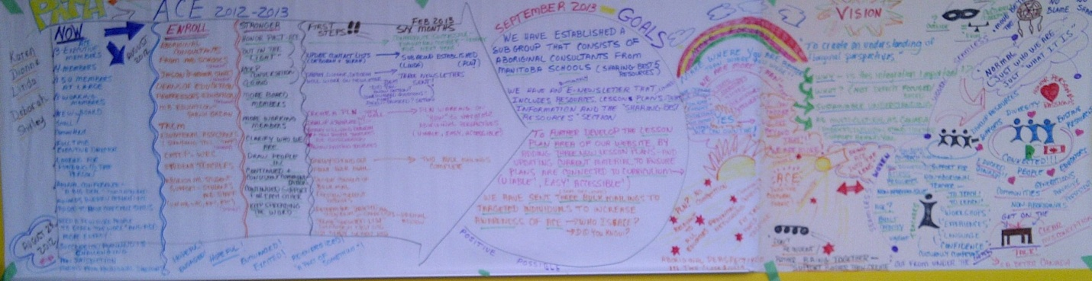
If you would like to see it up close and personal, it will be on display at the October 9, 2012 Member Meeting. Just let us know you’re coming so we can plan the noshes and nibbles.
There is a fundraiser at Essense for the Settee Brothers on September 29,
Check it out on facebook

More Event Information
Our 7th Annual Education Awards Banquet is still open for nominations!
Eight categories to honour someone who promotes Aboriginal perspectives in the classroom and beyond!
If you know of an Elder, educator or student who deserves to be recognised, please email awards@aboriginalcircleofeducators.ca for a Nomination Package, or visit the website and click on the link [Word format].

The Aboriginal Circle of Educators’
10th Annual A.C.E. Conference &
7th Annual Education Awards Banquet

Greenwood Inn, 1715 Wellington Avenue
Winnipeg, Manitoba

Please visit the A.C.E. Website,
www.aboriginalcircleofeducators.ca for Updated Presenter Information

The A.C.E. Education awards Banquet will be held on the evening of January 24, 2013 in the Greenwood Inn Evergreen Ballroom

While at the Conference and Banquet, be sure to check out the Exhibitor’s tables. Resources, crafts, jewelry and more will be available. Your support is appreciated.

This year’s Silent Auction promises to be as good as or better than last year’s!
There will be a star Blanket, resource materials and more.

Cultural Workshops are Coming!
A.C.E. has secured funding for a series of cultural workshops for educators and community members. Beading, jigging, drum making and star blanket making will be offered over the fall and winter. Participants will learn the basics of the activity as well as the traditional teachings. Educators will also have access to lesson plans and resources for classroom teaching. If you are interested in participating in any of these workshops, please contact the A.C.E. Office, 1.204.772.2231, or email workshops@aboriginalcircleofeducators.ca.

If there is a workshop you would like to see, please let us know.

Calling All Members!

As an A.C.E. Member, you have access to all kinds of interesting things, not only our Conference, Awards Banquets and workshops, but to our Meetings which always involved committed people and great food!

Meetings are usually held at the A.C.E. Offices, 2nd Floor- 765 Main Street at 4:15 pm. First comes the food and the chat with the meeting proper starting at about 4:30. Deborah loves to cook and usually has a soup or stew, bannock and salad available to those who make the trek. Latecomers be warned, there isn’t often leftovers.

In addition to the Meeting Dates listed below, there is also a PATH Meeting, held in the latter part of August. This all day meeting offers a fried fish and potluck dish Lunch as well as Nutrition Breaks.

December’s Meeting is the Annual General Meeting. Everyone is welcome and paid members have their dinner paid for [the cost of the Annual Membership is less than the Dinner….]

A.C.E. Meeting Dates 2012-13
Membership Meetings:

[Held the Second Tuesday of every Month]

- October 9, 2012
- November 13, 2012
- December 11, 2012
- January 8, 2013
- February 12, 2013
- March 12, 2013
- April 9, 2013
- May 14, 2013
- June 11, 2013
Conference Committee Meetings:

[Held the First Wednesday of most Months]

- October 3, 2012
- November 7, 2012
- December 5, 2012
- January 9, 2013
- January 23, 2013
- February 6, 2013
- April 3, 2013
- June 5, 2013

