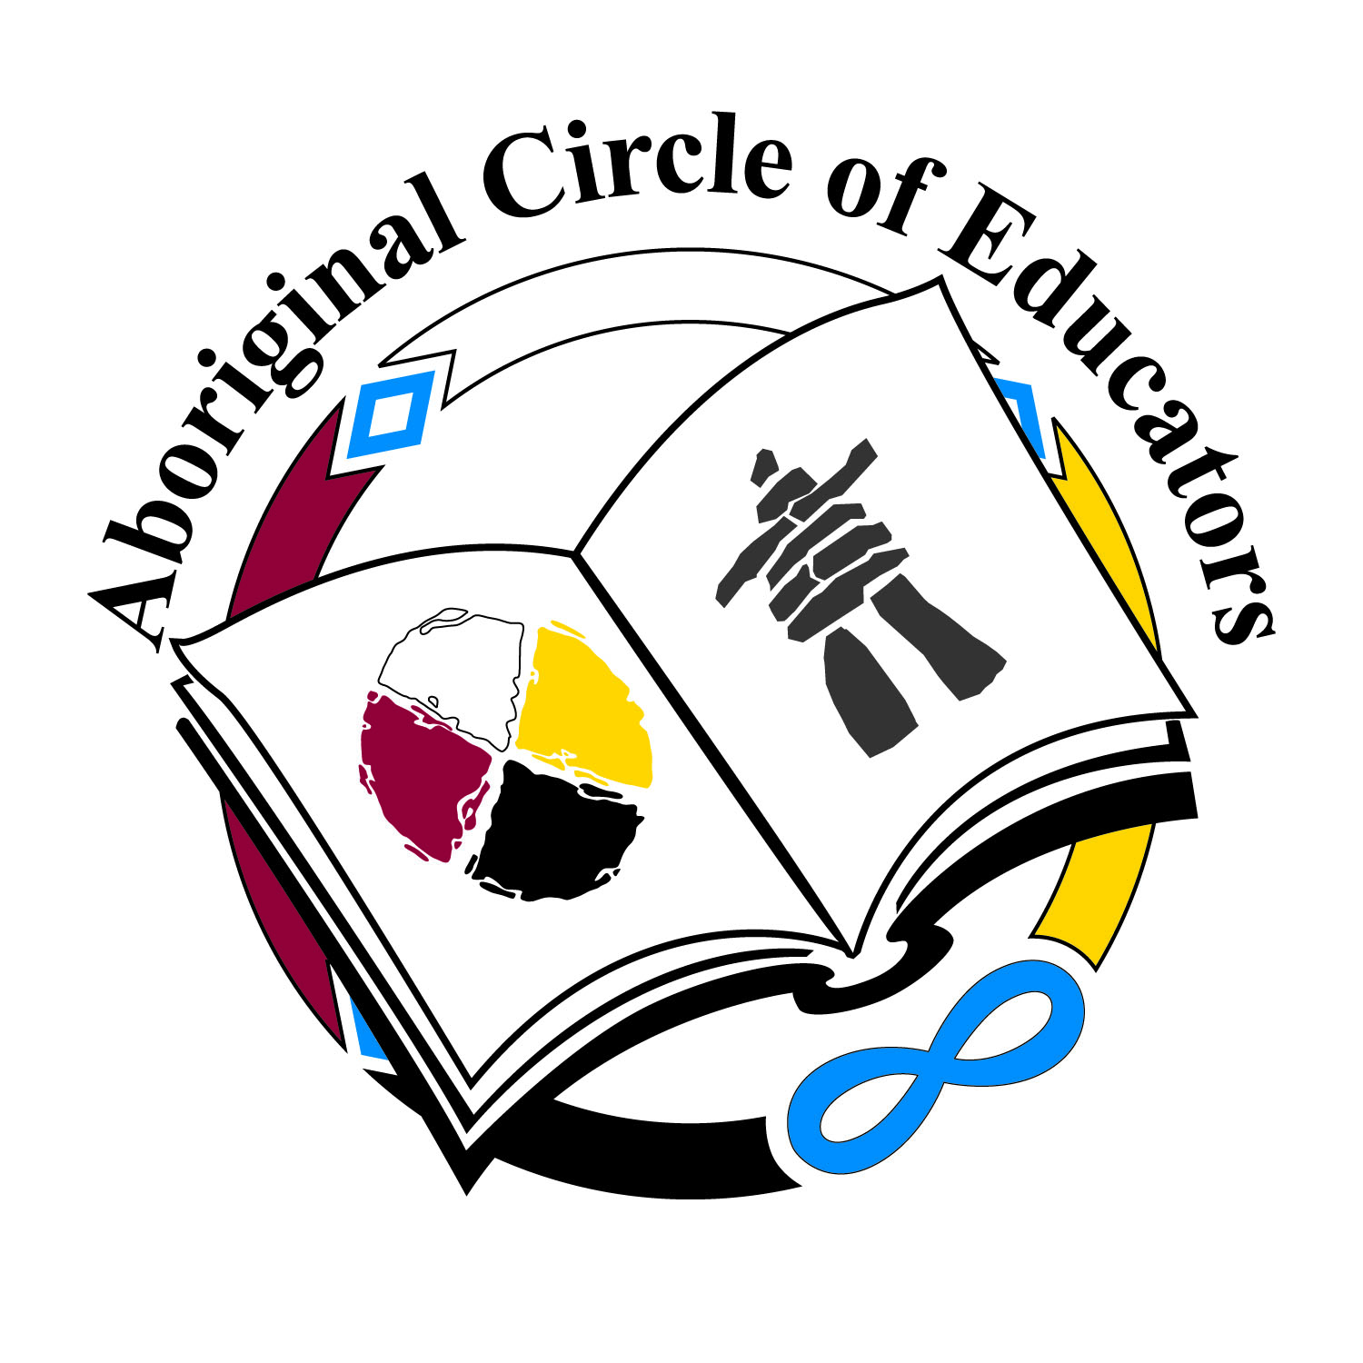 | Aboriginal Circle of Educators  715 Main Street, Winnipeg, Manitoba R3B 3N7  Phone 204.772.2231 Fax 204.772.2232  Email: ace@aboriginalcircleofeducators.ca  Website: www.aboriginalcircleofeducators.ca
13th Annual ACE Education Awards Gala  Honouring Our Traditions, Celebrating Our Future | The 16th Annual ACE Conference  “Sustaining Our Ways:  Gidinawenidimin: We Are All Related”
February 14-15, 2019

The Aboriginal Circle of Educators [ACE] is asking for your support.
We want to make this year our best year ever.

- Eagle Level Sponsors $10,000+ will receive:
  - Preferred E-Signage at the ACE Education Awards Gala and Conference
  - Recognition in ACE Programs
  - Preferred Recognition with Logo and Link on the ACE website
  - Preferred Reserved Table at the Awards Banquet
  - 2 Tickets to the Annual Conference
  - Preferred Trade Show Booth at the Conference
  - Acknowledgement in all e-newsletters

- Bear Level Sponsors $5,000 will receive:
  - E-Signage at the ACE Education Awards Gala and Conference
  - Recognition in ACE Programs
  - Recognition with Logo and Link on the ACE website
  - Reserved Table at the Awards Banquet
  - 2 Tickets to the Annual Conference
  - Trade Show Booth at the Conference

- Wolf Level Sponsors $2,500 will receive:
  - E-Signage at the ACE Education Awards Gala and Conference
  - Recognition in ACE Programs
  - Recognition with Logo and Link on the ACE website
  - Tickets for Two at the Awards Banquet
  - 2 Tickets to the Annual Conference
  - Trade Show Booth at the Conference

- Turtle Level Sponsors $1,500 will receive:
  - E-Signage at the ACE Education Awards Gala and Conference
  - Recognition in ACE Programs
  - Recognition with Logo and Link on the ACE website
  - Trade Show Booth at the Conference

- Table Sponsor $1,250 will be able to:
  - Attend the ACE Education Awards Gala for the organization
  - Or sponsor deserving individuals who could not otherwise attend

- Individual Sponsors $175+ will be able to:
- Sponsor a deserving individual in attending the Conference or Banquet [your choice]

The Aboriginal Circle of Educators has more than 200 Members throughout Manitoba and beyond.

